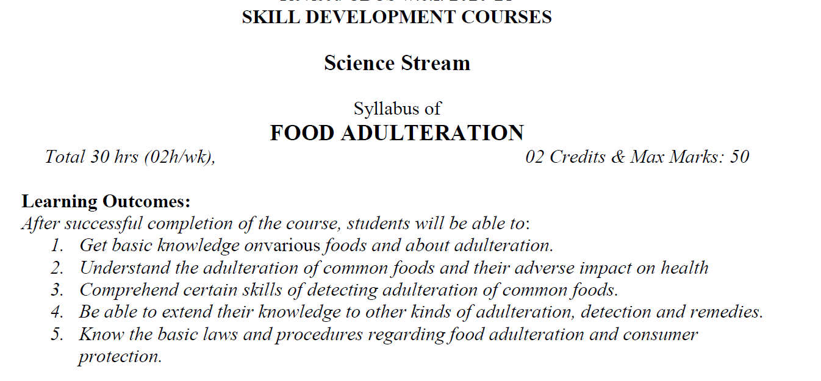

**Syllabus:**

**UNIT-I- Common Foods and Adulteration: (07 hours)**

Common foods subjected to adulteration-adulteration-Definition-Types: poisonous substances, foreign matter, Cheap Substitutes-Intentional and Incidental. General impact on human health.

**UNIT-II- Adulteration of common Foods and Methods of Detection: (10 hours)**

Means of Adulteration Methods of Adulterants in the following Foods: Milk, Oil, Grain, Sugar, Spices and Condiments, Processed food, Fruits & vegetables. (at least three methods of detection for each food item).

**UNIT-III- Present Loss and Procedures on Adulteration: (08 hours)**

Highlights of Food Safety and Standards Act 2006(FSSA)-Food Safety and Standards Authority of India-Rules and Procedures of Local Authorities.

Role of Voluntary agencies such as AGMARK, I.S.I, Quality Control Laboratories of companies, Private testing laboratories, Consumer Education, Consumer’s Problems Rights and responsibilities, COPRA 2019- Offences and Penalties- Procedures to Complain- Compensation to Victims.



